<https://github.com/Mayankgupta688/DecemberSession.git>

<https://github.com/Mayankgupta688/SessionNovember>

<https://medium.technofunnel.net/>

<https://prod.liveshare.vsengsaas.visualstudio.com/join?85733FE73BA357BB37228FC9BAB13A11B6C5>

javascript is purely functional, class is syntactical sugar

javascript prototype Chaining

(https://dzone.com/articles/prototype-amp-prototype-chaining-with-object-orien)

Reacts promotes functional programming

JavaScript hoisting (happens when it’s a function or var defined variables)

JavaScript Scoping - [JavaScript | Hoisting - GeeksforGeeks](https://www.geeksforgeeks.org/javascript-hoisting/)

[How V8 compiles JavaScript code ? - GeeksforGeeks](https://www.geeksforgeeks.org/how-v8-compiles-javascript-code/#:~:text=%20How%20V8%20compiles%20JavaScript%20code%20%3F%20,Stack%20of%20the%20V8%20engine%E2%80%99s%20runtime...%20More%20)

JavaScript Interpreted or Complied (double interpretation)

Kyle Simpson - Author

**Javascript - Async or Sync**

http://latentflip.com/loupe/?code=%3D%3D!!!

var data = 10;

var sum = 0;

setTimeout(function First() {

console.log("Data for SetTimeout 1 is: " + data)

}, 5000)

setTimeout(function Second() {

console.log("Data for SetTimeout 2 is: " + data)

}, 15000)

setTimeout(function Third{

console.log("Data for SetTimeout 3 is: " + data)

}, 10000)

console.log("Data from Outside" + data);

// 10 seconds

for(let i = 0 ; i < 100 ; i++) {

sum = sum + i

}

Not Single Threaded Architecture

Single Threaded Execution Model with multiple thread in the background for Async

(Call Stack,Web Api,Callback Queue)

<https://medium.com/technofunnel>

<https://www.w3schools.com/js/default.asp>

Context API, Closures

**ES6 – Features**

<https://www.boardinfinity.com/blog/top-10-features-of-es6/>

**let** - block scope/Lexical scope

**var** - function scope

const userDetails = {

name: "Raj"

age: 20

}

userDetails.age = 37

console.log(userDetails);

const dataArray = [1,2,3]

dataArray.push(4) // data can be changed,

//but new memory allocation is not allowed

console.log(dataArray);

const obj = {

prop: 42

};

Object.freeze(obj);

obj.prop = 33; // Throws an error in strict mode

**Spread and rest operators**

* Spread works with comma separated values
* copies and creates a new objects

const userDetails = {

name: "Raj",

age: 20,

designation: manager

}

var newDetails = {

…userDetails;

};

*Spread operator for an complex object*

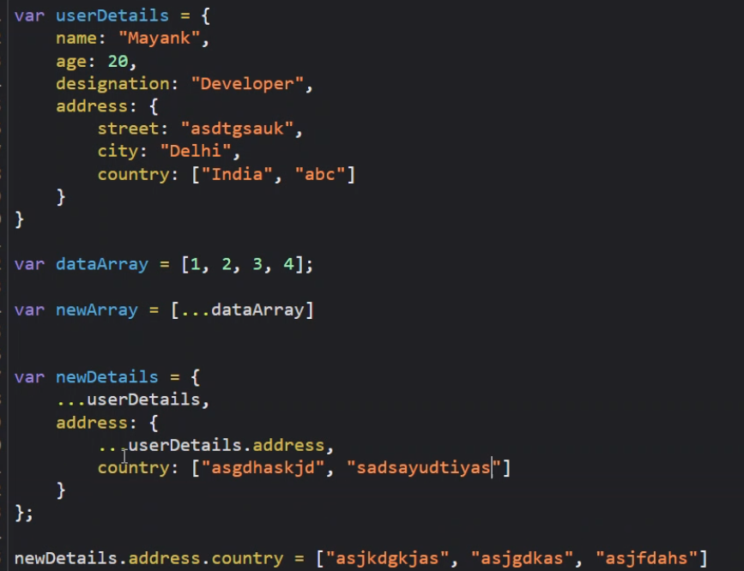

**Deep and Shallow Copies**

* <https://medium.com/@gamshan001/javascript-deep-copy-for-array-and-object-97e3d4bc401a>
* <https://www.freecodecamp.org/news/copying-stuff-in-javascript-how-to-differentiate-between-deep-and-shallow-copies-b6d8c1ef09cd/>

For in loop: <https://www.w3schools.com/jsref/jsref_forin.asp>

**Rest Operator**

//b will become will an array as the more two parameter

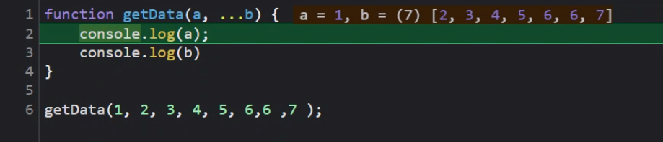

**Classes (prototype internally)**

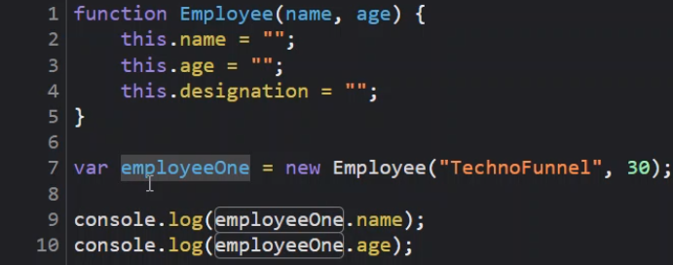

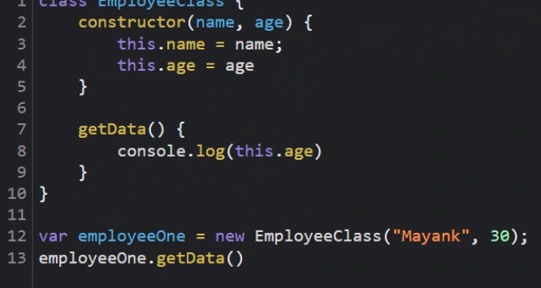

<https://www.typescriptlang.org/play>

Getdata function’s memory is allocated with Employee class not employeeOne object, this saves memory (prototype).

i.e class memory not object memory

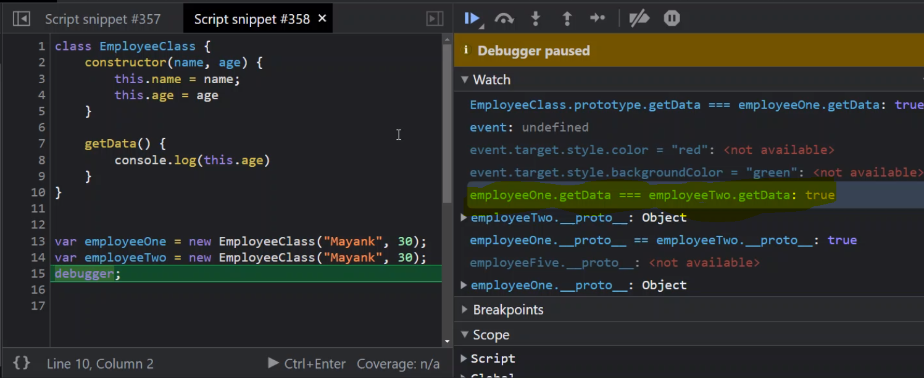

Prototype chaining

[**https://medium.com/developers-arena/javascript-classes-inheritance-and-prototype-chaining-es5-and-es6-way-4b8e9416702b**](https://medium.com/developers-arena/javascript-classes-inheritance-and-prototype-chaining-es5-and-es6-way-4b8e9416702b)

**Example:**

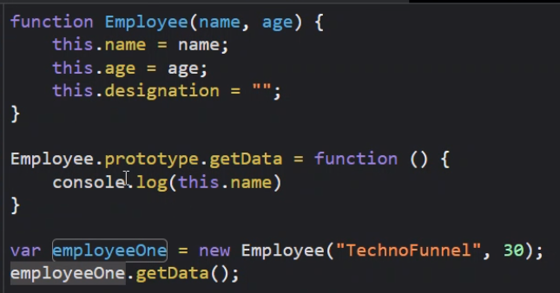

**Getting started – create react app**

npm install -g create-react-app

create-react-app employee-details

cd employee-details

npm start

**debugging steps**

npm cache clean –force

npm update npx

npm install npm@latest -g

Why Jsx – JSX allows us to write HTML elements in JavaScript and place them in the DOM without any createElement()  and/or appendChild() methods. JSX converts HTML tags into react elements.

Babel - Babel can convert JSX syntax!

<https://www.geeksforgeeks.org/jsx-full-form/#:~:text=Advantages%20of%20JSX%3A,()%20or%20createElement()%20method>.

Every component name must start with Capital letter.

import React from "react";

import ReactDOM from "react-dom";

import component, { HeaderComponent } from "./components/HeaderComponent";

import ContentComponent from "./components/ContentComponent";

import FooterComponent from "./components/FooterComponent";

alert(component)

ReactDOM.render((

    <div>

        <h1>These are the Application Components</h1><hr/>

        <HeaderComponent></HeaderComponent><hr/>

        <ContentComponent></ContentComponent><hr/>

        <FooterComponent></FooterComponent><hr/>

    </div>

), document.getElementById("root"));

Without JSX code will look like – html code becomes too complex and tedious to write. Example below:

import React from "react";

export default function HeaderComponent() {

    return React.createElement("div", null, [

            React.createElement("div", null,

                React.createElement("h1", null,

                    "This is my header")

            ),

            React.createElement("div", null,

                [

                    React.createElement("h1", null,

                        "This is my header"),

                    React.createElement("p", null,

                        React.createElement("h2", null,

                        "This is Non-Critical Header")

                        )

                ]

            )

        ]

    )

}

<div>

    <div>

        <h1>This is My Header</h1>

    </div>

    <div>

        <h1>This is My Header</h1>

        <p>

            <h2>This is Non Critical Header</h2>

        </p>

    </div>

</div>

**Interpolation aka Curly Braces**

export default function InterpolatingDataComponent() {

    function getData(){

            return "Raj"

    }

    var name ="Thyagaraju";

    var lname="Govardhan";

    return (

        <div>

            <h1>Hello World.... { getData()+ " " +  1 + 1 } </h1>

            <h1> { name +" "+lname } </h1>

        </div>

    )

}

**Read:** RxJs (Observables) / Generator

**Presentational Component**

**Destructing -** [**https://medium.com/@pyrolistical/destructuring-nested-objects-9dabdd01a3b8**](https://medium.com/@pyrolistical/destructuring-nested-objects-9dabdd01a3b8)

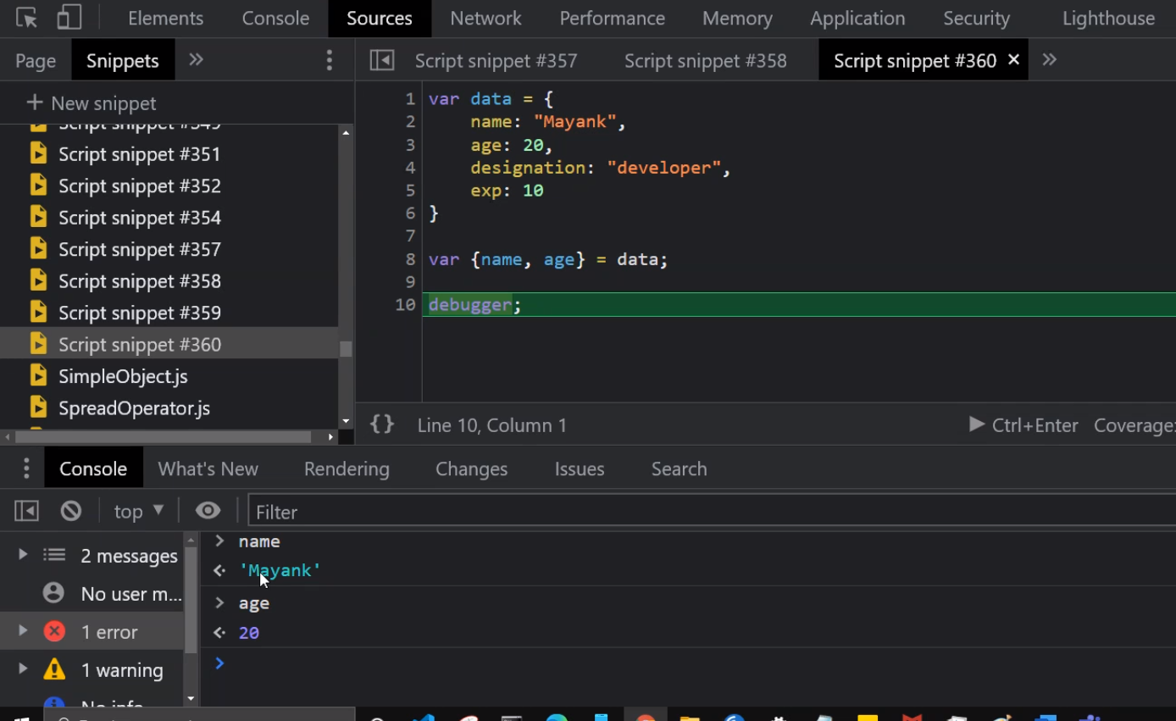 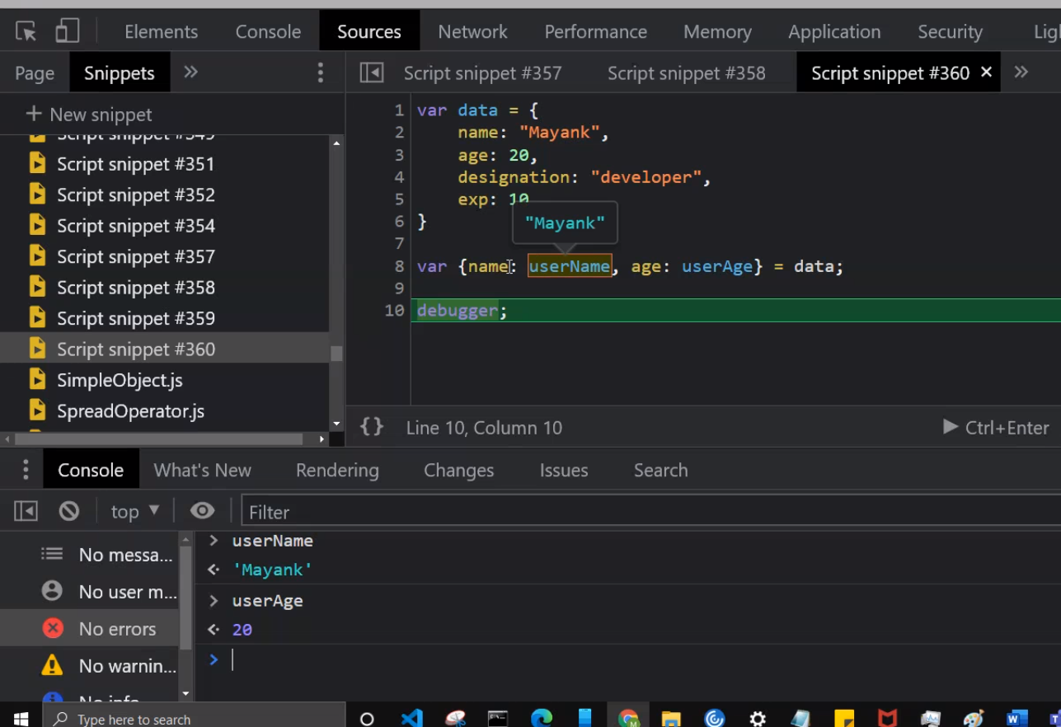

**Higher Order Functions**

A function that accepts and/or returns another function is called a **higher-order function**.

It’s higher-order because instead of strings, numbers, or booleans, it goes higher to operate on functions. Pretty meta.

With functions in JavaScript, you can

1. Store them as variables
2. Use them in arrays
3. Assign them as object properties (methods)
4. Pass them as arguments
5. Return them from other functions

<https://www.freecodecamp.org/news/a-quick-intro-to-higher-order-functions-in-javascript-1a014f89c6b/>

**Use of Map function**

export default function EmployeeListComponent() {

    return (

        <div>

            { employeeList.map((emp,index) => {

                return (

                    <div className="card">

                        <img src={emp.avatar} class="card-img-top" alt="..." />

                        <div className="card-body">

                            <h5 className="card-title">{emp.name}</h5>

                            <p className="card-text">Some quick example text to build on the card title and make up the bulk of the card's content.</p>

                            <input type="button" value={"Delete " + emp.name} className="btn btn-primary" />

                        </div>

                    </div>

                )

            })}

        </div>

    )

}

**Use of Filter function**

 function getEventDetails(event, employeeId) {

        //debugger;

        employeeList = employeeList.filter((emp) => {

            return emp.id !== employeeId

        })

        alert(employeeList.length)

    }

**Promises -** [**https://javascript.info/promise-basics**](https://javascript.info/promise-basics)

**Class Component:**

**Life cycle -** [**https://reactjs.org/docs/react-component.html**](https://reactjs.org/docs/react-component.html)

**Mounting**

These methods are called in the following order when an instance of a component is being created and inserted into the DOM:

1. constructor()
2. static getDerivedStateFromProps()
3. render()
4. componentDidMount()

**Updating**

An update can be caused by changes to props or state. These methods are called in the following order when a component is being re-rendered:

1. static getDerivedStateFromProps()
2. shouldComponentUpdate()
3. render()
4. getSnapshotBeforeUpdate()
5. componentDidUpdate()

**Unmounting**

This method is called when a component is being removed from the DOM:

1. componentWillUnmount()

**Error Handling**

These methods are called when there is an error during rendering, in a lifecycle method, or in the constructor of any child component.

1. static getDerivedStateFromError()
2. componentDidCatch()

**State Component:**

import React from "react";

export default class TimerComponent extends React.Component {

    constructor() {

        super();

        this.state = {

            time: this.getCurrentTime()

        }

        setInterval(() => {

            this.setState({

                time : this.getCurrentTime()

            })

            console.log(this.state.time);

        }, 1000)

    }

     getCurrentTime() {

        var currentDate = new Date();

        return currentDate.getHours() + " : " + currentDate.getMinutes() + " : " + currentDate.getSeconds();

    }

    render() {

        return (

            <div>

                <h1>Current Time is: {this.state.time}</h1>

            </div>

        )

    }

}

**This keyword and bind function**

**Read: call, bind and apply**

**Arrow function preserves this current context**

getEventDetails = (event) => {

        debugger;

        var updatedList = this.state.employeeList.filter((emp) => {

            return emp.id !== event.target.id

        })

        this.setState({

            employeeList: updatedList

        })

    }

<input type="button" id={emp.id} value={"Delete " + emp.name} onClick={this.getEventDetails} className="btn btn-primary" />

**Or**

export default class EmployeeListingClass extends React.Component  {

    constructor() {

        super();

        this.state = {

            employeeList: empList

        }

        this.sampleData= {

            name: "adfhakgkjs"

        }

        this.getEventDetails = this.getEventDetails.bind(this);

    }

**Or**

**Use bind function on**

<input type="button" id={emp.id} value={"Delete " + emp.name} onClick={this.getEventDetails.bind(this)} className="btn btn-primary" />

**Typescript – Provides type safety**

**Read – Controlled and Uncontrolled element in relation with Dom Difference**

**Uncontrolled elements are the ones not managed/controlled by React. i.e not having JSX markup**

[**https://reactjs.org/docs/uncontrolled-components.html**](https://reactjs.org/docs/uncontrolled-components.html)

**SetState is Async**

[**https://stackoverflow.com/questions/33613728/what-happens-when-using-this-setstate-multiple-times-in-react-component**](https://stackoverflow.com/questions/33613728/what-happens-when-using-this-setstate-multiple-times-in-react-component)

**React detects if setState called multiple time, then will batch setState operations, this is done for performance.**

**Chaining setState:**

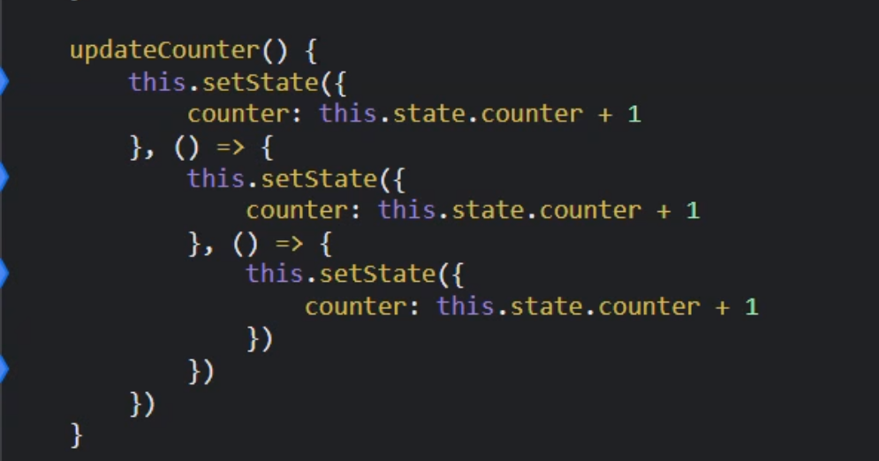

**Axios mock api -** [**https://5a530e1477e1d20012fa066a.mockapi.io/login**](https://5a530e1477e1d20012fa066a.mockapi.io/login)

[**https://priceapi.moneycontrol.com/pricefeed/nse/equitycash/NAC**](https://priceapi.moneycontrol.com/pricefeed/nse/equitycash/NAC)**​**

[**https://priceapi.moneycontrol.com/pricefeed/bse/equitycash/SBI**](https://priceapi.moneycontrol.com/pricefeed/bse/equitycash/SBI)

shouldComponentUpdate

componentDidMount

**Read:**

[**https://www.geeksforgeeks.org/reactjs-pure-components/**](https://www.geeksforgeeks.org/reactjs-pure-components/)

[**https://stackoverflow.com/questions/42756354/should-i-use-react-purecomponent-everywhere**](https://stackoverflow.com/questions/42756354/should-i-use-react-purecomponent-everywhere)

[**https://medium.com/welldone-software/react-when-should-pure-components-be-used-56c4428fe970**](https://medium.com/welldone-software/react-when-should-pure-components-be-used-56c4428fe970)

[**https://medium.com/technofunnel/working-with-react-pure-components-166ded26ae48**](https://medium.com/technofunnel/working-with-react-pure-components-166ded26ae48)

[**https://stackoverflow.com/questions/54374046/what-is-the-meaning-of-mutable-state-in-react-forms-or-generally**](https://stackoverflow.com/questions/54374046/what-is-the-meaning-of-mutable-state-in-react-forms-or-generally)

"Mutable" in programming refers to anything that can change during the running of a program. The [dictionary definition](https://www.dictionary.com/browse/mutable) is "liable or subject to change or alteration".

The opposite would be "[Immutable](https://en.wikipedia.org/wiki/Immutable_object)" (i.e. something that cannot change). In the context of a React component, this would be the props.

So, in the context of a form, the mutable state would be made up of the contents of the inputs that make up the form. (Unless of course you set one of those inputs to be read only!)

**Observables – RxJs**

npm install --save rxjs

Both Observables are promises are Aysnc

<https://stackoverflow.com/questions/37364973/what-is-the-difference-between-promises-and-observables>

**RxJs** –

Offering a powerful, functional approach for dealing with events and with integration points into a growing number of frameworks, libraries, and utilities, the case for learning Rx has never been more appealing.

Read Subjects

A Subject is a special type of Observable which shares a single execution path among observers.

Very important –

[Subjects - Learn RxJS](https://www.learnrxjs.io/learn-rxjs/subjects)

[Introduction - Learn RxJS](https://www.learnrxjs.io/)

[Understanding RxJS Subjects, Behavior Subjects, and Replay Subjects Using a Deck of Cards | by Benni Russell | Medium](https://medium.com/@bennirus/understanding-rxjs-subjects-behaviour-subjects-replay-subjects-with-a-deck-of-cards-5e5a3aac096f)

Subject vs Behavioural subject – Subject does not provide initial value, Behavioural subject

Provides first initial value to the subscriber.

Using subject you can wire communication between parent, child and siblings also

**React Hooks**

**What is a Hook?** A Hook is a special function that lets you “hook into” React features. For example, useState is a Hook that lets you add React state to function components. We’ll learn other Hooks later.

**When would I use a Hook?** If you write a function component and realize you need to add some state to it, previously you had to convert it to a class. Now you can use a Hook inside the existing function component. We’re going to do that right now!

<https://reactjs.org/docs/hooks-intro.html>

Functional component ability to own data i.e., State

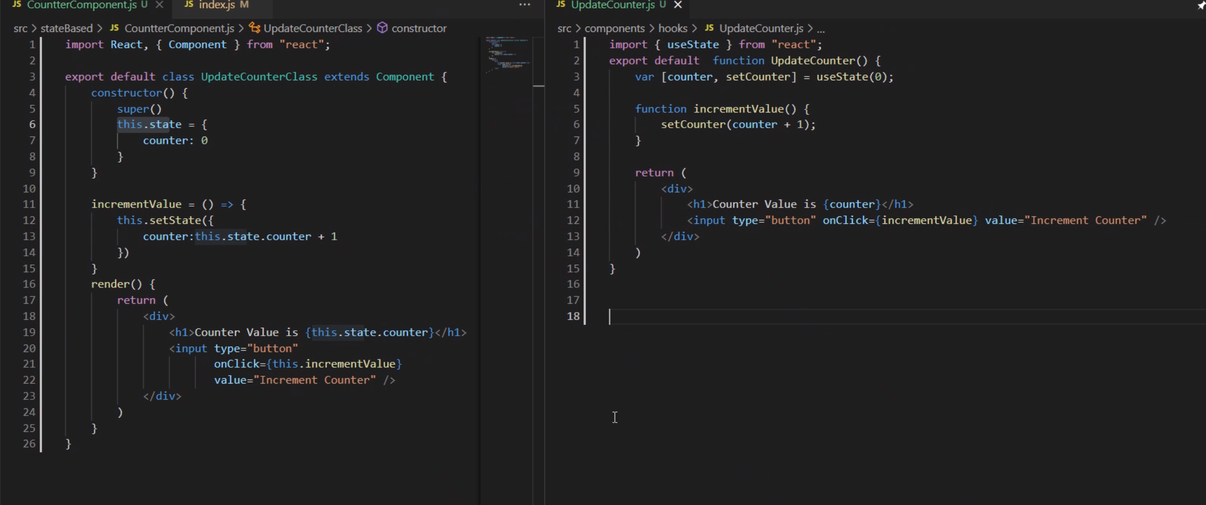

[Making setInterval Declarative with React Hooks — Overreacted](https://overreacted.io/making-setinterval-declarative-with-react-hooks/)

SetInterval is called once and is not destroyed. SetTimeout is calls itself after an interval and is destroyed immediately

[React Class Component vs Functional Component: How To Choose (telerik.com)](https://www.telerik.com/blogs/react-class-component-vs-functional-component-how-choose-whats-difference)

[Arrow Functions vs. Regular Functions in JavaScript | by Chameera Dulanga | Bits and Pieces (bitsrc.io)](https://blog.bitsrc.io/arrow-functions-vs-regular-functions-in-javascript-458ccd863bc1)

Using arrow functions has performance impact as it does not use prototype and hence

It will be object/class’s memory. Use normal for prototype benefit.

**UseEffect**

Data fetching, setting up a subscription, and manually changing the DOM in React components are all examples of side effects. Whether or not you’re used to calling these operations “side effects” (or just “effects”), you’ve likely performed them in your components before.

**What does useEffect do?** By using this Hook, you tell React that your component needs to do something after render. React will remember the function you passed (we’ll refer to it as our “effect”), and call it later after performing the DOM updates. In this effect, we set the document title, but we could also perform data fetching or call some other imperative API.

**Does useEffect run after every render?** Yes! By default, it runs both after the first render and after every update. (We will later talk about [how to customize this](https://reactjs.org/docs/hooks-effect.html#tip-optimizing-performance-by-skipping-effects).) Instead of thinking in terms of “mounting” and “updating”, you might find it easier to think that effects happen “after render”. React guarantees the DOM has been updated by the time it runs the effects.

<https://css-tricks.com/run-useeffect-only-once/>

**The problem with that is that if you’re doing something like fetching data from an API, you might end up double-fetching which is inefficient and unnecessary.**

### The trick is that useEffect takes a second parameter.

### The second param is an array of variables that the component will check to make sure changed before re-rendering. You could put whatever bits of props and state you want in here to check against. See example below

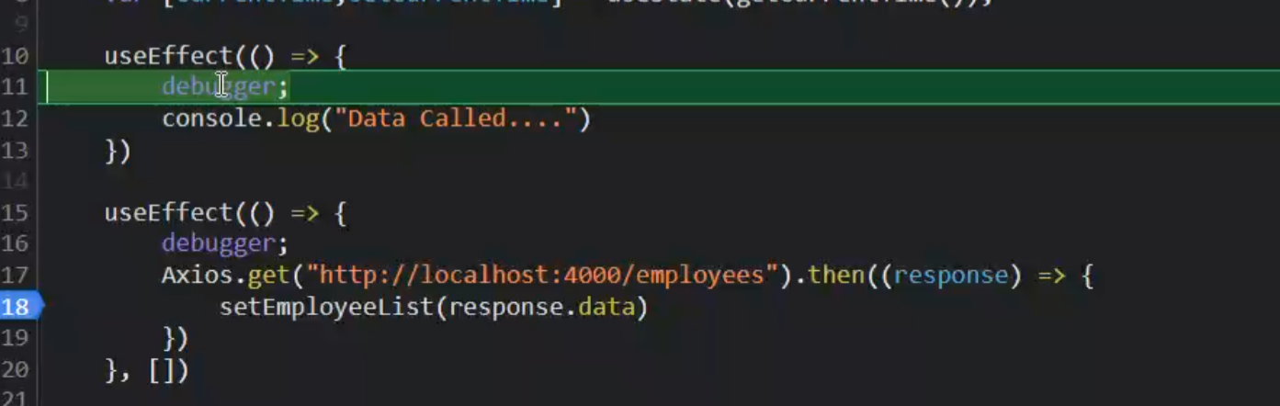

**Destructing useEffect**

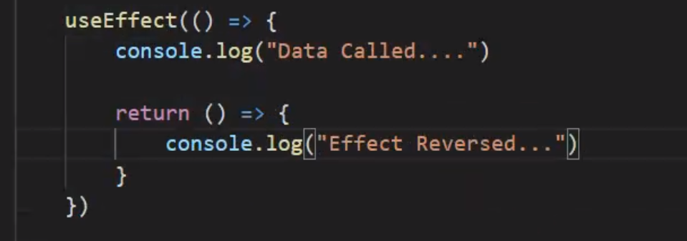

First run the destructor/remove effect and then run the use Effect again.

**Forms in React using Hooks**

<https://www.freecodecamp.org/news/beginner-react-project-build-basic-forms-using-react-hooks/>

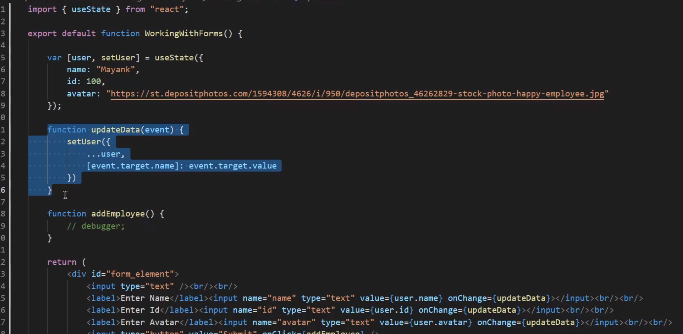

**Context API**

<https://www.loginradius.com/blog/async/react-context-api/>

<https://www.toptal.com/react/react-context-api>

Only rule is there should be a parent and child hierarchy

**Custom hooks**

[**https://www.freecodecamp.org/news/how-to-create-react-hooks/**](https://www.freecodecamp.org/news/how-to-create-react-hooks/)

Used to develop business logic component involving data.

Custom hooks can expose data and setData/getData(function)

function useStockData() {

    var [stock, setStock] = useState(400);

    var [nalcoStock, setNalcoStock] = useState(100);

    setTimeout(() => {

        Axios.get("https://priceapi.moneycontrol.com/pricefeed/bse/equitycash/SBI").then((responseSbi) => {

            setStock(responseSbi.data.data.pricecurrent);

        })

        Axios.get("https://priceapi.moneycontrol.com/pricefeed/nse/equitycash/NAC").then((responseNalco) => {

            setNalcoStock(responseNalco.data.data.pricecurrent);

        })

    }, 2000)

    return [stock, nalcoStock];

}

export default function StockExchangeComponent() {

    var [sbiStockPrice, nalcoStock] = useStockData();

    return (

        <div>

            <h1>Listing Interesting Stocks</h1>

            <h3>Sbi Stock Value {sbiStockPrice}</h3>

            <h3>Sbi Stock Value {nalcoStock}</h3><hr/><hr/>

            <StockExchangeComponentChild></StockExchangeComponentChild>

        </div>

    )

}